Status and Plan for the Central Preshower

D. Alton, A. Askew, P. Baringer, D. Coppage, J. Gardner, A. Magerkurth, Y. Maravin, J. Qian

Abstract
The D0 central preshower detector is designed to improve electron and photon identification and to restore some of the electromagnetic energy resolution, which is otherwise degraded by the presence of the solenoid. This document will give a brief description of the detector, describe its current operating capabilities and the plans for how to operate it in the long term. Specifically this document discusses why the CPS group plans on changing the operating gain at the end of the Oct. 2003 shutdown.

1) Introduction
The central preshower (CPS) is situated between the solenoid and the central calorimeter. It is constructed from a lead radiator outside the solenoid and triangular scintillator strips arranged in three cylindrical layers surrounding that. The light from the scintillator is wavelength shifted by fibers that are inserted in the center of the triangular scintillator, this fiber is then coupled to a clear waveguide. The waveguide carries the light to VLPC cassettes (described in more detail elsewhere) that transform that light into an electrical signal that is read out of AFE boards. Details of its construction can be found in D0 Notes 3014, 3647, and 3765. One change from note 3014, which people often miss is that the idea of tapered lead was never implemented. Another major change between the detector designed and implemented is that the AFE boards used only have one electronics channel per detector channel, while the design called for 2 readout channels with different gains. This would have allowed a larger dynamic range.

The central preshower has been fully instrumented and operating since Apr. 17, 2002. It has run in two different modes and probably will run in a third soon. The different modes are changes to the electronics gain, which basically means operating with different dynamic ranges. The first transition in gain occurred Nov. 1 2002, and we plan to change the gain again on Nov. 22 2003. We believe this change will be the last change of its kind unless the collaboration decides to pursue creation of AFE II’s, which is still under study. This document is being created and released now, to give all of D0 the chance to comment on these plans before they go into effect. To allow for educated comments, the document will include a section that describes the current status and capabilities of the detector. Following that we will describe what we believe the right way to operate the detector is and why.

2) Current status
In order to understand the status it helps to recognize the goals at design. The CPS had two basic goals: to aid in electromagnetic (EM) identification, and to recover electromagnetic energy resolution, which was lost by introduction of the solenoid and other material in the tracking volume. Electromagnetic identification can be further broken down into: fake electron rejection, a soft electron tag for b-jet identification, and separation of π⁰ from γ. The energy resolution has a more continual nature, in that we don’t have the dynamic range to improve the resolution everywhere. What energies coupled to the saturation point (and the electronics gain).

This section will discuss the current alignment, reconstruction efficiency, calibration, and energy studies.

2a) Alignment
The alignment is in good shape, but can still be improved. The expected spatial resolution for the gain we are operating is 1.5 mrad in phi (2.5 mm in z) for 50 GeV electrons. In electrons from Z’s, we find a resolution of 1.58 mrad (3.2 mm). There is some evidence for a misalignment, and Don Coppage has agreed to try to improve this. Note that Monte Carlo studies indicate reducing the gain ought to improve this resolution to about 1.0 mrad (1.8 mm) for high pt (50 GeV) electrons, however if there is a misalignment much of that improvement will not be realized.

2b) Reconstruction Efficiency
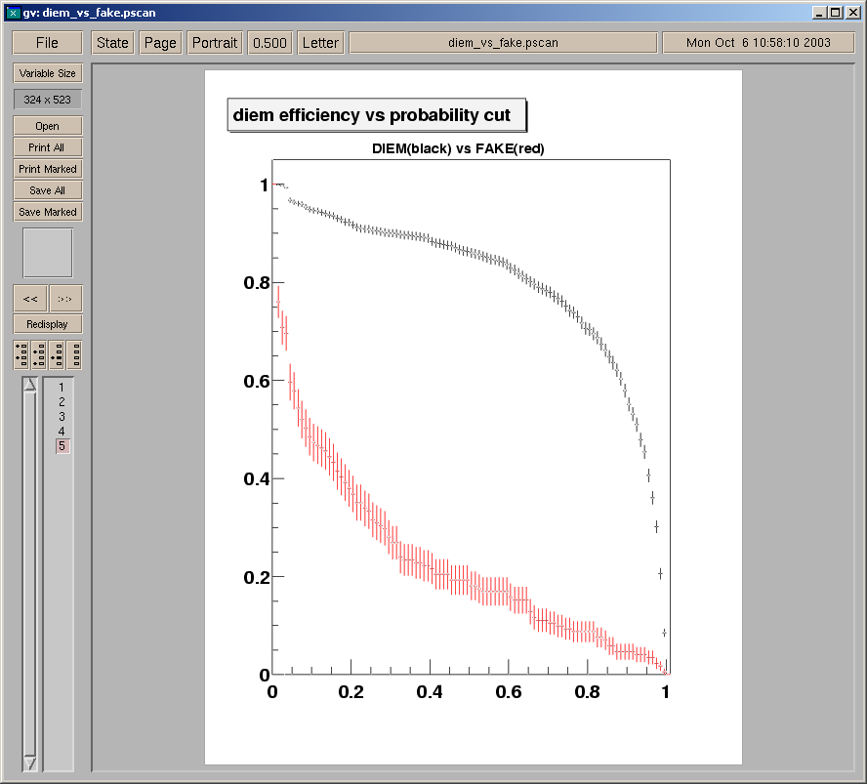

Figure 1 - test the efficiency for electrons to pass a cut based on the CPS discriminate,
for a sample of Z candidates (black) and QCD-EM objects (red).

Studies have indicated that the CPS is about 97% efficient for EM objects. It is hard to define efficiency here, because as one opens up the window on a spatial match one allows fake matches, so to demonstrate the usefulness John Gardner has constructed a discriminate based on CPS variables. He uses default reconstruction, which is described in D0 Note 4014. He used a sample of Z candidates as the signal and a sample of QCD-EM events as the background. The results are shown in Figure 1.

2c) Calibration
The calibration of the CPS was driven by results presented in D0 Notes 3535 and 3572 these results explained that the cps needed channel by channel calibrations that were good to approximately 10%. The basic idea was that energy would be defined:
Energy = (ADC- <Pedestal>)/MIP
Where ADC is the read out ADC value, <Pedestal> is the mean ADC value of the pedestal, and MIP is the separation between the mean of the Pedestal and the most probable value of the minimum ionizing particle peak.
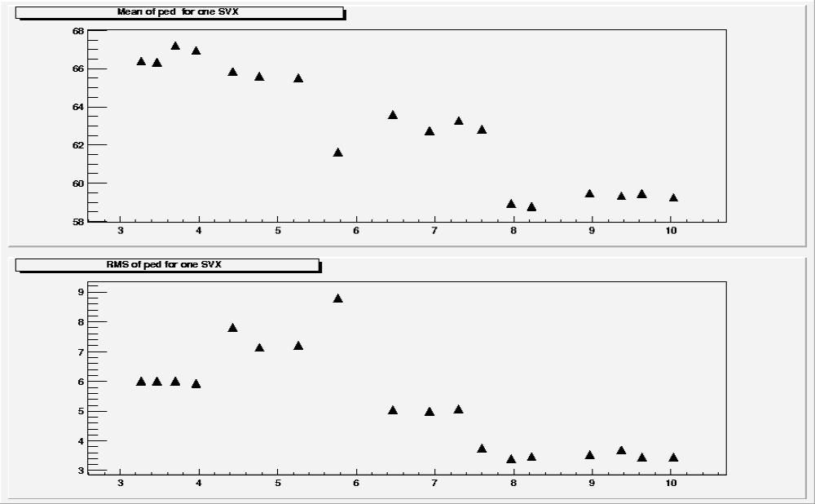
March
October
3
9
58
68

Figure 2 - the average pedestal value for 64 channels, and the RMS of those 64 channels over an eight month time span. Each line represents a known change. The first line is swapping AFE boards to implement cryo modifications, the second is when sequencer firmware changed, the third is new clockgen code, the fourth was an attempt to implemented 264 readout, and the last was correctly implementing 264 readout.

The pedestal mean is extracted on a channel by channel basis from the calibration for the whole central fiber tracker (CFT) system. The pedestal mean is very constant over long time scales.

Figure 2 shows the mean pedestal for 64 channels, and the RMS of the mean of those channels over an eight month time period in 2002. The vertical lines represent known changes in either the hardware or firmware of the AFE board. One can see that except for these known changes the pedestal is constant over months. However the pedestal does change on short timescales; specifically it has a crossing dependence. As most people know the Tevatron has 36 filled crossings per turn, these crossings are divided in to 3 super-bunches each with 12 filled crossings. The pedestal in the CFT system varies as a function of these 12 crossings. Figure 3 shows the pedestal deviation as a function of crossing from its nominal value for an individual channel.

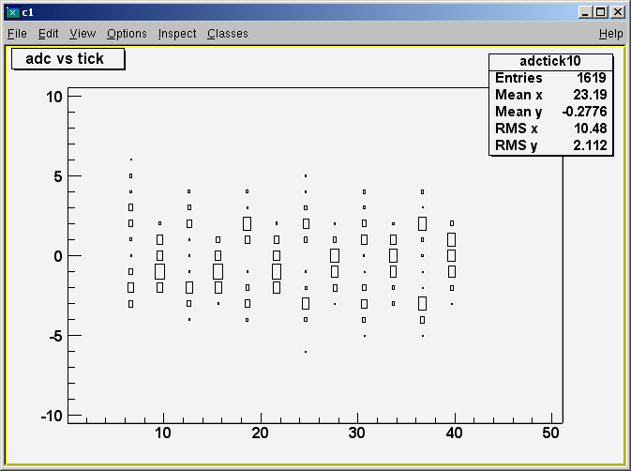

Figure 3 - The pedestal deviation from nominal as a function of tick, for a specific CPS channel.

The pedestal splits, by about 5 ADC for the odd numbered crossings, and is slightly (about 1 ADC) above nominal for the first crossing. The behavior of the first crossing wouldn’t deserve comment except that this effect is larger in the tracking portion of the system. Neither of these problems are serious for most uses of the CPS, because EM objects leave 10’s of MIP’s in the detector and these effects are at the level of half a MIP or less; however they do complicate the identification and measurement of the MIP signal. Additionally this could be a significant bias in the energy measurement, if all the pedestals split up or down uniformly. There are studies underway to remove this effect.

Measurement of the MIP peak is complicated by the way the pedestal issues cited above cause the threshold to be set higher than originally anticipated. Previous studies (D0 Notes 3765 and 3572) indicated that the zero suppression threshold would be around 1 photoelectron or roughly of 1/10th of a MIP, however we find that we need to operate with the threshold more like a third of a MIP. A threshold this high will influence the measurement of the MIP peak value. Additionally the thresholds are not very uniform. Due to these issues it became clear that one could not simply look at isolated singlets to perform the MIP calibration. Instead, we found we needed to look at isolated singlets which were matched to a track.
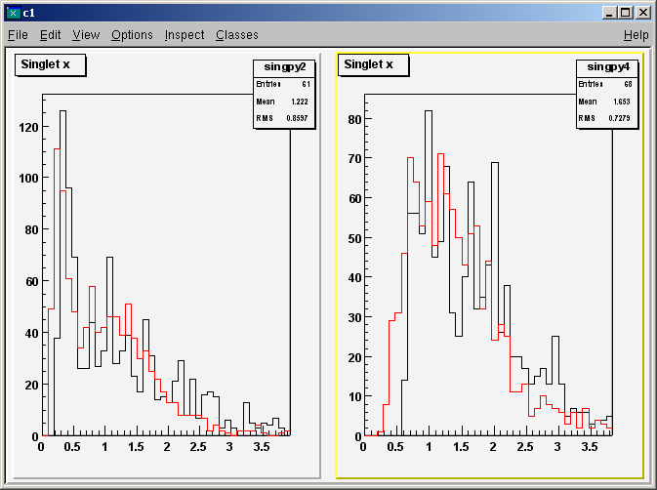
Figure 4 - shows the extracted MIP distribution for two channels which have specific types of behavior.

The MIP distribution is shown in Figure 4 for 2 channels. The black distribution is the energy defined above, and the red has been corrected for path length as determined by the track eta. (Recall that tracks that pass through the scintillator at an angle give off more light than those with normal incidence.) These channels are chosen to represent two types of anomaly. Specifically note that the channel on the right has a very hard left hand threshold, while the one on the left shows a bit of the pedestal leaking in. These differences are correlated to channels on a specific chip of the AFE boards. It turns out that it is difficult to automate fitting of the left hand channels, while it is easy to automate fitting channels like the right hand channel, however there is a large uncertainty in the fit of the right hand channel due to the possibility that the threshold is significantly cutting into the MIP peak. For a handful of chips these two channels were fit as well as possible by hand, and their ratios were taken. It is believed the two sets ought to have the same light yield on average; however the channels on the right measured a mean 1.11 ± 0.07 times more ADC then those of the left. While this is statistically negligible it gives us some feeling for the systematic uncertainty associated with these fits. Another measure of the systematic uncertainty is to refit the same set of data. The initial calibrations were extracted from 100,000 events in physics run 167,663, the same technique was used to extract a value for the MIP after applying the initial calibration. The sample used had a large overlap with the original sample. In principle this should result in every channel giving exactly 1. The distribution of values is found in Figure 5a.

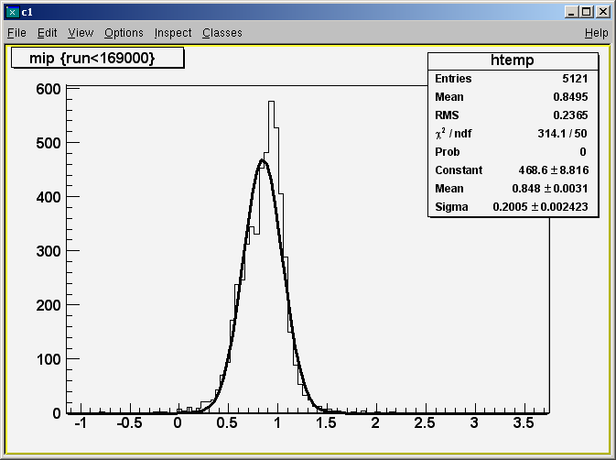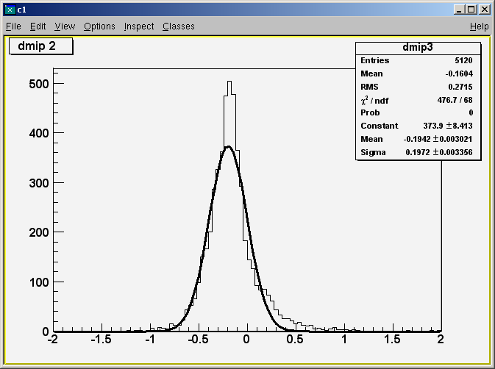
Figure 5 - 5a shows the distribution of re-extracted MIP values in the same sample as they were originally extracted. Figure 5b shows difference in MIP extracted from run 167663, and those extracted from 175054, divided by the value measured in 175057.
Figure 5b shows the difference between the number extracted the second time run 167663 was processed and the value extracted from run 175054 (5 months later). Note that this includes movement of electronics (AFE boards), which occurs occasionally and has not been removed.

The issues above demonstrate that it will be very difficult and conceivably impossible to achieve calibration errors of 10%. The bright side of this is that the value of the calibration seems stable at the same level of its initial uncertainty so that recalibration isn’t necessarily an important aspect. Given these concerns it was decided to re-examine the need for 10% uncertainty; which will be addressed later.

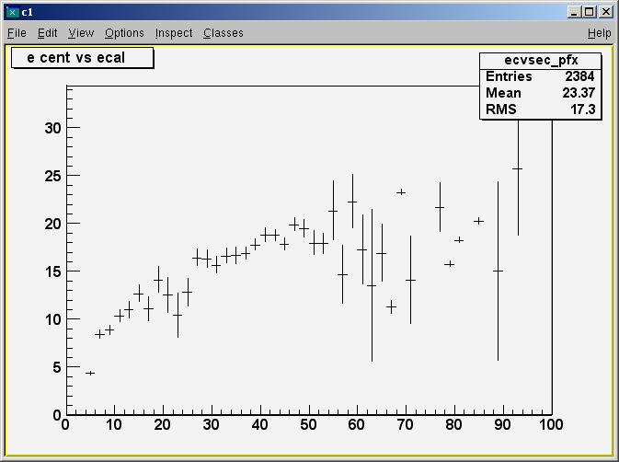
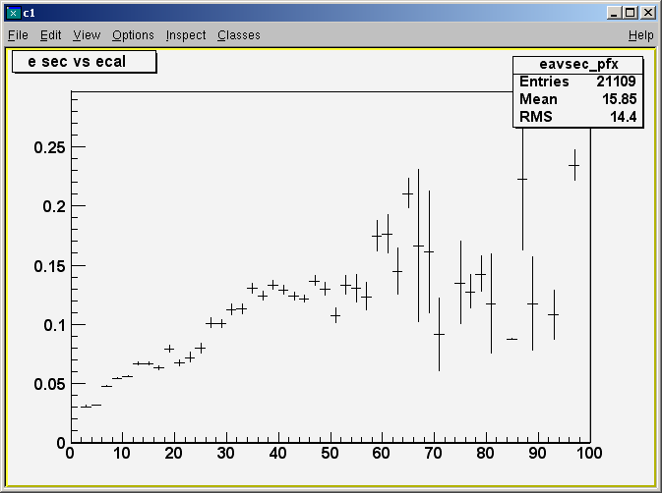

Figure 6 - 6 a and b are a sample of Z and J/ψ to electrons from the data, 6a shows the average strip energy of the central strip in MeV versus the reconstructed calorimeter pt, and 6b shows the CPS cluster energy in GeV versus the reconstructed calorimeter pt.
2c) Energy measurement
Figure 6a and b show energy correlations between the calorimeter and the central CPS strip and the calorimeter and the whole CPS cluster respectively. The central strip is saturated at about 25 GeV, and that the whole cluster becomes insensitive (due to saturation) by about 35 GeV. Due to this (and the meagerness of our J/ψ to electrons sample at the time), attempts to improve the energy resolution have used Monte Carlo (MC) samples.

This set of studies on EM energy resolution started with a sample of Z to electron MC, where each strip of the CPS was made to saturate at 60 MeV. One can match reconstructed electrons to truth electrons with a 0.2 x 0.2 (eta x phi) box, and define:
χ2 = Σ(α0*Ecps + α1*Eem1 + α2*Eem2 + α3*Eem3 + α4*Eem4 + α5*Efh –Emc)

When one minimizes with respect to the layer weights (α) one gets a set of 6 linear equations for 6 unknowns and one can solve the matrix to find the optimal layer weights. One can also do this ignoring the CPS terms and this was done so that you can see how much it affects the results to apply the layer weights to the same sample they were extracted from. If one then fits a gaussian to the distribution of :
(α0*Ecps + α1*Eem1 + α2*Eem2 + α3*Eem3 + α4*Eem4 + α5*Efh –Emc)/E_{mc}
The results using the original layer weights (ie straight from the MC) one finds a resolution of (3.34 ± 0.04)%, with layer weights extracted without the CPS it is (3.42 ± 0.04)%, and including the CPS one gets (3.01 ± 0.04)%. There is a relative improvement of 10%.

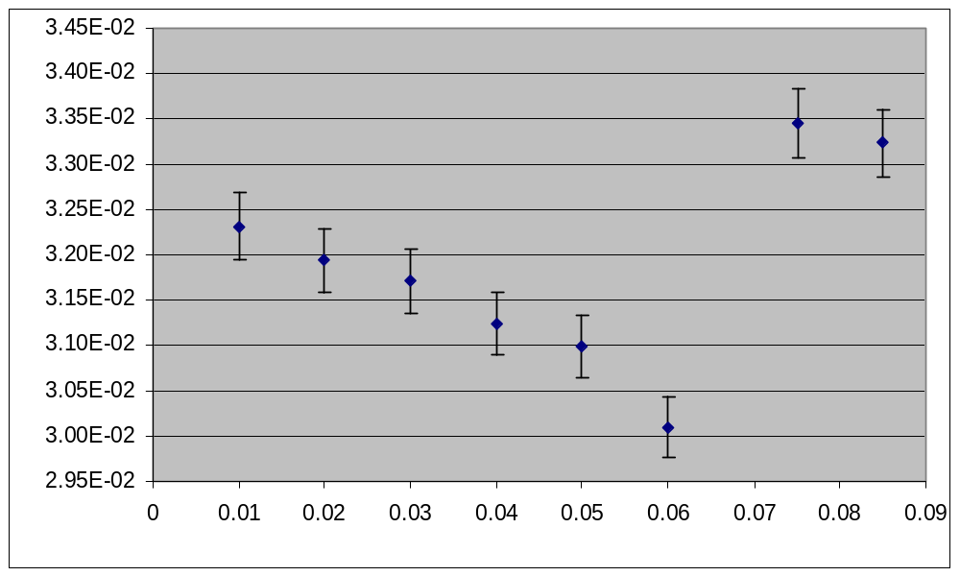

Figure 7 - shows the strip saturation in GeV along the x axis, and the energy resolution on the y axis, however the last two points are the calorimeter only resolutions.

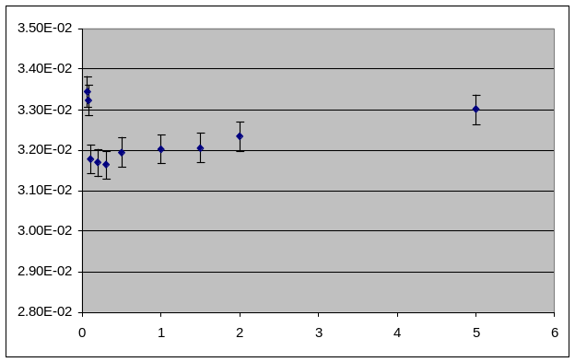
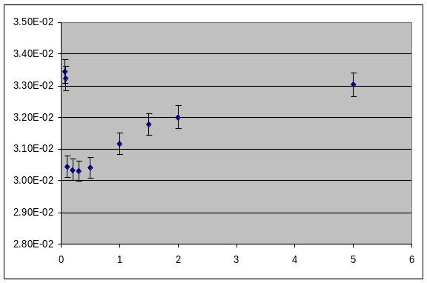

Figure 8 - 8a shows how calibration uncertainty affects the energy resolution for a saturation of 20 MeV. Note that the first 2 points are calorimeter only. For the MC sample each strip was smeared by a gaussian with a mean of the correct (original Monte Carlo) value and a sigma which is the number along the x axis times the correct value. So when the x axis is 1, the energy is smeared by 100%. Figure 8b shows the same thing for a saturation of 60 MeV.

The results of the saturation study are shown in Figure 7, and indicate that higher saturation is better for electrons from Z’s. Single electron MC was studied to see how things behave if saturation cutoffs larger than 60 MeV are used, and the resolution flattens out. Further studies also showed that one could achieve improvements of 15% if one used larger clusters and allowed non-contiguous ‘clusters’. Now we shall examine how saturation and calibration affect that. The results from smearing the calibrations are shown in Figure 8a and b. The results of the saturation and smearing studies clearly indicate that it is better to have a large uncertainty on the energy than to saturate. These studies seem to indicate that a 50% uncertainty on the relative calibrations is ok, but that is in conflict with note 3535. Further investigation revealed that the original study smeared the whole CPS energy by 10%, which is not representative of calibration uncertainties.

3) Summary and Plans
In summary, the CPS is basically ready for all uses, except improving the EM energy resolution for high pt EM objects. Nothing has been shown for γ-π⁰ separation, studies have begun and there are no known problems. It is felt that the improvement in EM resolution offered by the CPS is nearly essential to a W mass analysis. We plan to change the gain such that strips with 60 MeV saturate, which means that electrons with pt’s around 75 GeV will have saturated strips. Additionally electrons with around 35 GeV pt will saturate if they have the highest eta that still hit the CPS, however generally this type of electrons hit the ICD region and are not used for analysis. This section will discuss other options we have, what damage could be caused by this, and present the detailed plan.

3a) Other options
There are two basic ideas for other ways to deal with this problem. These ideas are to treat the detector as a digital calorimeter (ie. count strips) or model the energy lost by saturation and correct for the effect. Both ideas have been briefly studied.

In the MC studies discussed above it was discovered that a better improvement on energy resolution was possible by integrating all energy in an eleven-strip window. (This technique will be more sensitive to occupancy and overlaid min-bias events, and thorough studies should be done to determine what the best technique is long term.) Using this technique a relative improvement of 15% was achieved. That is to say the resolution with the calorimeter and CPS is 15% better than the resolution of just the calorimeter. Using the same 11 strip window but counting strips rather than summing energy one achieves a resolution which is 10% better than the calorimeter alone. Which gets one back to the clustered energy result.

A simple model of the energy lost due to saturation being a linear function of the energy in the nearest unsaturated strips worked well. Using the MC we applied saturation, but kept track of how much energy was lost by saturation, and extracted a slope and intercept from correlations to the nearest unsaturated strips. If one corrects using this model one finds that the energy is smeared by about 10%.

Both of these techniques provide reasonable alternatives to changing the gain on the detector. They aren’t as good, but they come close.

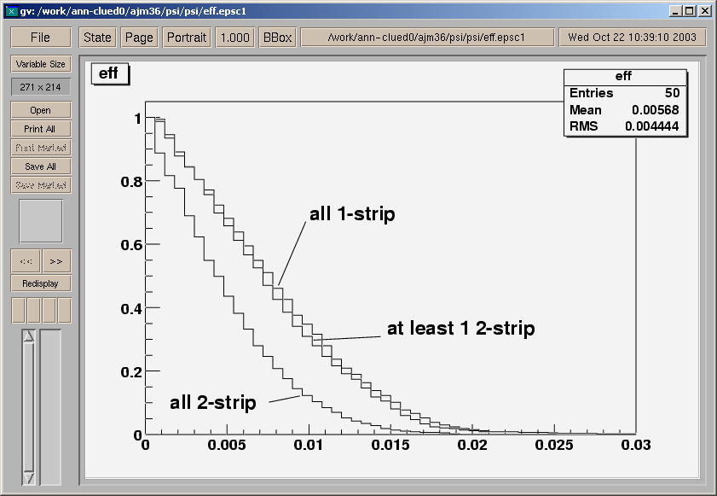
Figure 9 - Figure 9 shows the fraction of J/y electrons with 1 or more strips per layer as a function of the strip threshold in GeV. The lowest line has all three layers of the CPS having at least 2 strips. One can see that a strip threshold above ~ 2 MeV cause noticeable inefficiency.

3b) The downside to changing.
There are a number of effects, which may cause problems if we change the gain. First off, the energy now has a larger granularity. The MIP peak would now be 6 ADC counts above the pedestal mean. So further calibration at this gain will be basically impossible. The other worry is that changing the gain may negatively impact things for the low energy EM objects. The ways that could happen, is that the readout threshold would effectively rise and reduce the efficiency for making CPS clusters, or reduce the number of strips in those cluster which would reduce the information in them.

Note that calibration issues above indicate that recalibration isn’t necessary. If someone wants to test the channel by channel calibration at a later date some special runs would be required, but could occur only every few months. The other worry concerning how many strips are in a cluster is addressed by looking at J/ψ events. Figure 9 shows the efficiency for the cluster attached to a J/ψ electron to have 1 or more strips in each CPS layer. When a cluster has only 1 strip, its spatial resolution isn’t as good, so those have been shown. The current threshold is around 1/3 of a MIP (or around 0.4 MeV), and we plan to change the threshold by about a factor of 3, so in the worst case the threshold would be around 1 MIP (or 1.2 MeV). This would mean around 10% of clusters have only 1 strip for at least 1 layer, however the efficiency for finding clusters would still be in the high 90’s. This study makes us comfortable that the change (in the worst case) only has a small impact on the lower energy EM objects and conceivably has no nearly zero impact.

3c) The Plan
While a reasonable fraction of the benefit of changing the gain can be achieved by other means, all the studies indicate that the risks to the lower energy physics is small, and so we still plan to change the gain. The gain change has two components that can be addressed separately: The overall change in dynamic range (which we have focused on), and the idea that we can make the detector have a more uniform saturation value. The uniform saturation value is being pursued to make analysis and simulation of the detector simpler. Currently the experiment is in an accelerator driven shutdown. This shutdown will end on or around Nov 11. The plan is to come up from the shutdown in this new configuration where each SVX that reads out the CPS is adjusted to try and give the best dynamic range, and made to have as uniform a saturation point as possible. The saturation point that will be aimed for is 60 MeV (at this saturation it is believed less than 10% of electrons from Z’s will have a saturated strip). Currently there are no plans to recalibrate in the future. The efforts of the CPS group will be focused on making data and MC agree, and improving the software.

4) Summary
The CPS is ready for use. The one thing that is less than optimal is it’s improvement in energy resolution for high pt electrons, but that will be fixed after Nov. 11th 2003. Please let us know if you feel we have forgotten something, or if you feel our efforts should be devoted elsewhere.

